Report
The Carbon Impact of AI Video Generation
Part 1
9 March 2026, technical specification for review

About the report
This report serves as part 1 in a series of reports that seeks to provide our current best view of the carbon impacts of AI video generation. We recognise that this is a fast moving and rapidly changing space and the intention is to bring clarity to our understanding of how AI video generation is being used in media today and how its carbon impact is currently measured and understood.

Acknowledgments
The Carbon Trust wrote this report based on an impartial analysis of primary and secondary sources, including expert interviews.
The Carbon Trust would like to thank everyone that has contributed their time and expertise during the preparation and completion of this report. Special thanks goes to:
This report was funded through DIMPACT members. For the avoidance of doubt, this report expresses independent views of the authors.

About the Carbon Trust
Our mission is to accelerate the move to a decarbonised future.
We have been climate pioneers for more than 20 years, partnering with leading businesses, governments and financial institutions globally. From strategic planning and target setting to activation and communication - we are your expert guide to turn your climate ambition into impact.
We are one global network of 400 experts with offices in the UK, the Netherlands, South Africa, China, Singapore and Mexico. To date, we have helped set 200+ science-based targets and guided 3,000+ organisations in 70 countries on their route to Net Zero.

About DIMPACT

 | The Carbon Trust’s mission is to  accelerate the move to a decarbonised future.

Authors:
Matt Anderson
Technical advisor
Matt.Anderson@carbontrust.com
Bob Burgoyne
Associate Director
Bob.Burgoyne@carbontrust.com
Wei Yang Lee
Senior Associate
WeiYang.Lee@carbontrust.com
Mike Hopkins
Senior Consultant
Mike.Hopkins@carbontrust.com
Fedra Bartfai
Senior Analyst
Fedra.Bartfai@carbontrust.com

- Measuring the carbon impact of generative AI
A key objective of this report is to propose a best practice methodology for how generative AI-related emissions should be estimated and reported for video generation. In doing so, we aim to improve how well we measure and understand the carbon impact of generative AI from a lifecycle perspective. We also aim to encourage transparency and consistency in how the carbon impact of generative AI is measured and reported so that we can make more informed decisions about how we use this technology.
In this section, we review existing studies and methodologies, to assess completeness and consistency with carbon accounting standards (such as GHG Protocol Product Standard and ISO 14067) and principles and propose a view on best practice in this area.
  - AI system lifecycle boundary
    - Boundaries established in literature and existing methodologies
The AI system lifecycle may be defined as below in Figure 8 which follows the AI system from inception (where the idea for the model is initially conceived and explored), through design, verification, deployment, operation and ultimately retirement. Green Software Foundation’s Software Carbon Intensity for AI (SCI for AI) defines a similar lifecycle to include inception, design and development, deployment, operation and monitoring and end-of-life.

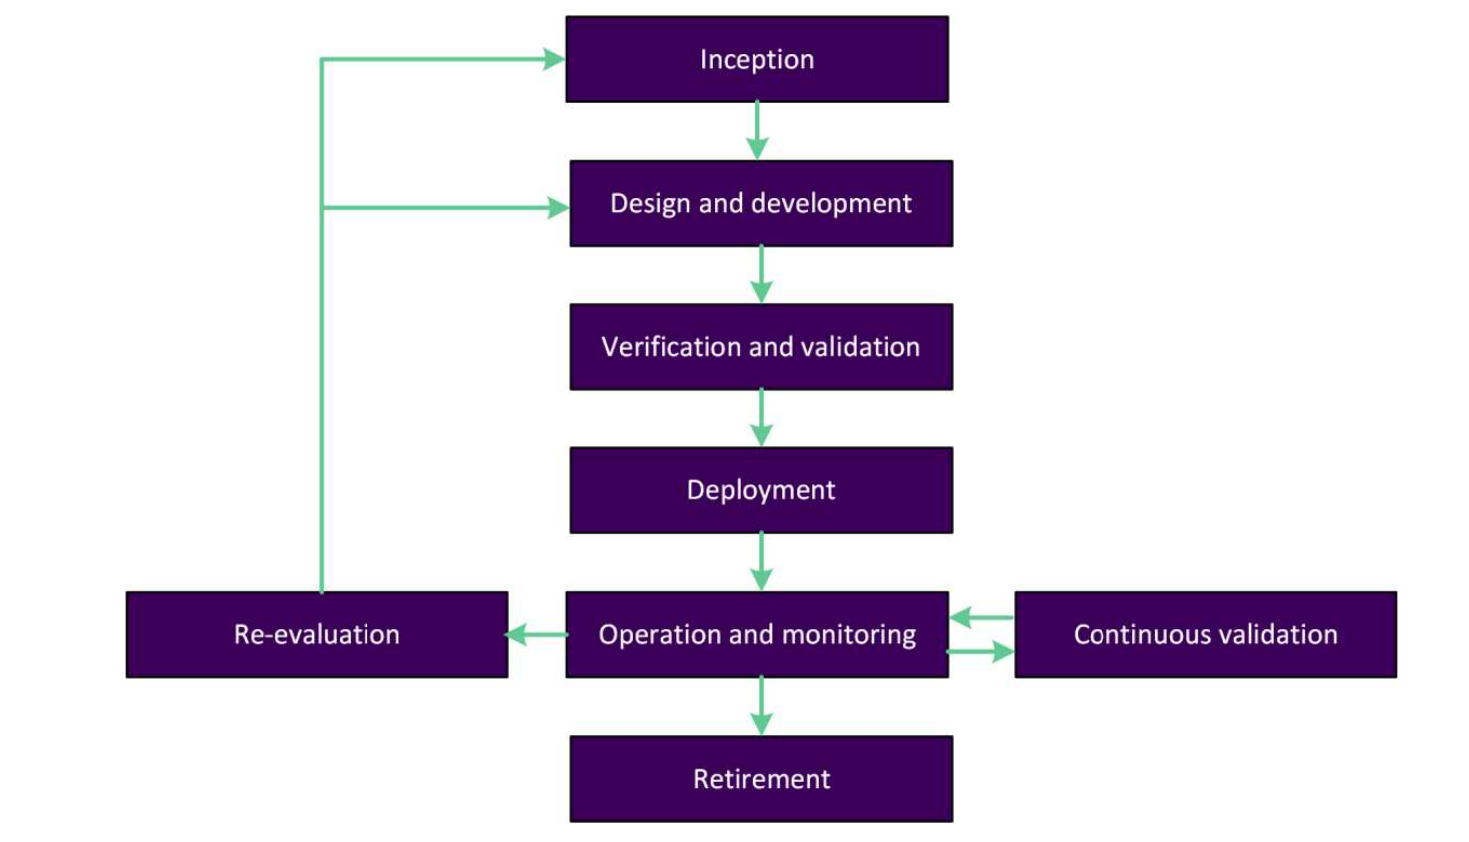
Figure 8. AI system lifecycle as defined by AFNOR Spec 2314 (AFNOR, 2024)
The AI system lifecycle follows an iterative approach, where the model is continuously validated and periodically re-evaluated and potentially retrained during its lifecycle. This lifecycle view ensures that these processes are captured within the lifecycle boundary.
Table 2. Comparison of boundaries used in literature and current methodologies to assess energy and carbon impact of generative AI systems
Study/  Source | IT hardware boundary |  |  |  |  |  | Operational boundary |  | Embodied boundary |  |  | End-of-life (decomm-issioning)
Study/  Source | GPU | CPU | Memory | Network-ing | Storage | Idle capacity | IT hardware | Support services (e.g., MEP/PUE) | IT hardware | Building infrastructure |  | End-of-life (decomm-issioning)
 |  |  |  |  |  |  |  |  |  | Building structure | Support services | End-of-life (decomm-issioning)
AFNOR Spec 2314 | Y | Y | Y | Y | Y | U | Y | Y | Y | O | O | Y
GSF SCI for AI | Y | Y | Y | Y | Y | Y¹ | Y | Y | Y | O | U | Y
ICT Sector Guidance* | Y | Y | Y | Y | Y | Y² | Y | Y | Y | O | O | U
Patterson et al (2021) | Y | Y | Y | Y | U | U | Y | Y | N | N | N | N
Wu et al (2022) | Y | Y | Y | Y | Y | U | Y | Y | Y | N | N | N
Luccioni et al (2022) | Y | N | U | P | P | U | Y | Y | P³ | N | N | N
Faiz et al (2024) | Y | Y | Y | Y | Y | U | Y | Y | Y | N | N | N
Legend | Y = Yes (in boundary) |  | N = No (outside boundary) |  | P = Partially in boundary |  | O = Optional/recommended |  | U = Unspecified

Notes for Table 2
*The ICT Sector Guidance Built on the GHG Protocol Chapter 4 covers Data Centre Services, but does not explicitly address AI systems
1. Determined via requirements of GSF Software Carbon Intensity (SCI) specification
2. If provisioned for the service
3. GPU and servers
Leading product carbon footprinting (PCF) standards (such as the GHG Protocol Product Standard), define the lifecycle stages as shown in Figure 8, which include material acquisition and processing, as well as production, distribution & storage, use and end-of-life. This example also demonstrates how, for a company that manufactures a product such as a car, the product lifecycle stages map to scopes 1, 2 and 3 as used in organisational reporting.
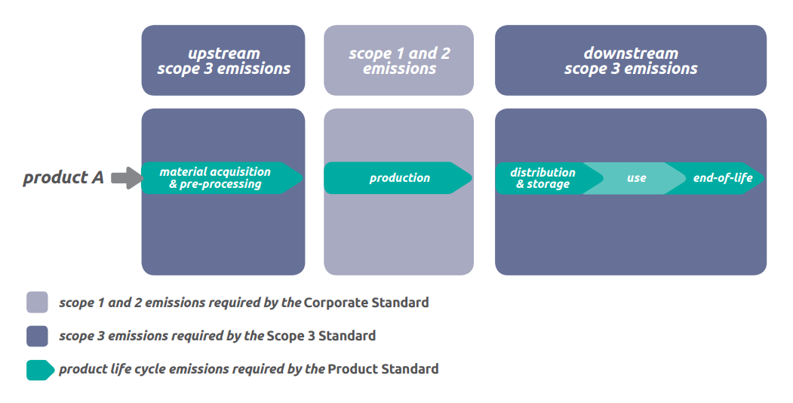
Figure 9. GHG Protocol Product Standard lifecycle stages and their relationship with the GHG scope 1, 2 and 3 emissions for a company that produces “product A” (Greenhouse Gas Protocol, 2011)
Building on the AI system lifecycle defined by existing methodologies and applying the approach from PCF standards, we assess in Table 2 how these approaches treat the various elements of the AI system. Specifically, we are interested in reviewing which elements are included in the operational boundary (such as the energy used by IT hardware and support services in a data centre), which elements are included in the embodied boundary (such as the production and end-of-life emissions of IT hardware and building infrastructure) and how the end-of-life of the AI system is treated.
Among the three established methodologies (AFNOR, GSF and GHGP ICT Sector Guidance), we see a good degree of consistency.
All of the key IT hardware components fall within the footprinting boundary, both from an operational and embodied carbon perspective. Support services (such as cooling, lighting and other overhead) are included as well across all three. Typically, idle capacity and end-of-life of the AI system (i.e., decommissioning) are included in the lifecycle boundary, but in some cases these are not explicitly addressed.
We also note that while embodied carbon of IT hardware is included in the lifecycle boundary, the embodied carbon related to the data centre building structure and support services are either left as an optional inclusion or not addressed explicitly.
When reviewing studies from literature that evaluate the environmental impacts of AI models, we note a higher degree of inconsistency and an inclination to focus primarily on the operational emissions.
    - Proposed generative AI system lifecycle boundary
In Figure 10 we propose our view of an appropriate boundary to evaluate the lifecycle carbon impact of an AI system. This is broadly consistent with the methodologies established by AFNOR Spec 2314 and GSF’s SCI for AI. For completeness and clarity, we explicitly identify idle capacity, embodied carbon (of IT hardware, building structure and support services) and retirement/decommissioning as within boundary.
Note that ultimately the boundary is intrinsically linked to the function of the product or service being evaluated. For more on this subject see Section 4.2.

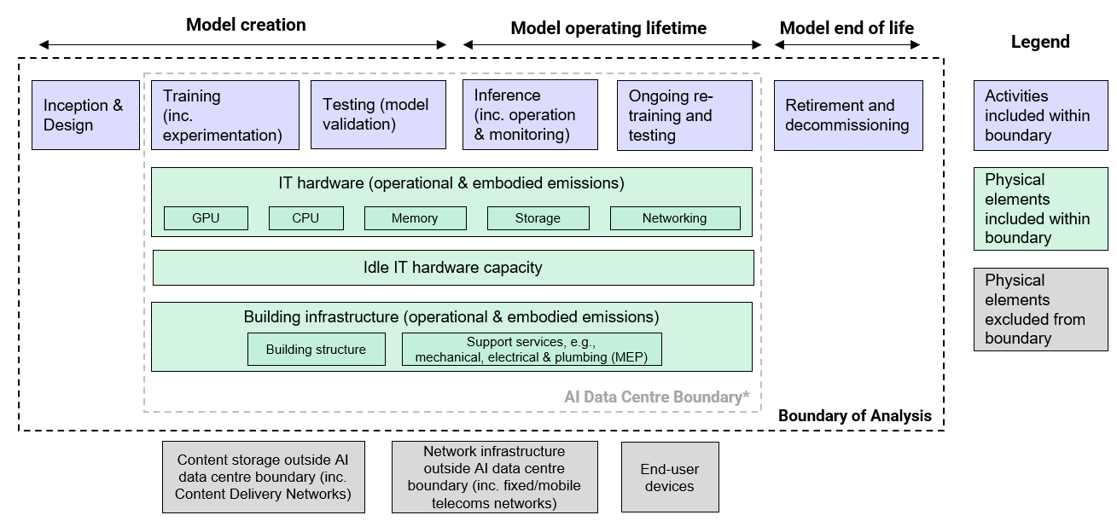
*The AI data centre boundary will comprise multiple data centres in different locations and with different purposes e.g. model training will often be carried out in data centres with tailored IT hardware for this task.
Figure 10. Proposed AI system lifecycle boundary
Treatment of idle capacity in data centre IT hardware
Regarding idle capacity, we have observed from Google’s recent study on the environmental impact of text generation that both overhead from support services and idle machines are a significant contributor to the total operational energy consumption during inference (8% and 10%, respectively) (Elsworth, et al., 2025). We also observe that in the Amazon Web Services (AWS) Customer Carbon Footprint Methodology v3.0, the approach inherently captures idle capacity through IT hardware assigned, but not necessarily fully utilised, to the service (Amazon Sustainability, 2025).
We therefore expect that emissions from idle hardware capacity to be significant and should be included in the boundary.
Assessment of materiality of embodied carbon of building infrastructure
The embodied carbon of IT hardware is generally well understood as being material and therefore recommended for inclusion in the AI system lifecycle boundary (see Figure 6). However, the materiality of embodied carbon from the building infrastructure (e.g., building structure and support services) are less understood.
We evaluate this subject and determine that in many cases, but not all, we expect embodied carbon from the data centre building structure and support services to be relatively immaterial. We perform this assessment by comparing the embodied carbon emissions per m² of data centre floor space, amortised over the life of the building, to an annual carbon impact of IT hardware per m². We establish a materiality threshold of 1% relative to the emissions of IT hardware.
In our analysis, the embodied carbon is amortised over a 60-year period and rack power densities are evaluated from 5 kW per m² to 22 kW per m². We develop a low, medium and high scenario for the carbon impact of IT hardware by further varying the emissions intensity of electricity.
Table 3. Materiality assessment of embodied carbon of data centre infrastructure
Emission source | Value | Unit | Ratio embodied/IT (>1% = significant) | Note
Embodied | 117 | kgCO₂e/m²/year |  | Assume 7000 kgCO₂e/m² for building and MEP over  60 yr life
IT (low) | 896 | kgCO₂e/m²/year | 13% | Assume 5 kW/m² (50 kW/rack), 50% utilisation, located in France
IT (med.) | 22,944 | kgCO₂e/m²/year | 0.51% | Assume 12 kW/m², 65% utilisation, located in Virginia, USA
IT (high) | 63,062 | kgCO₂e/m²/year | 0.19% | Assume 22 kW/m² (130 kW/rack), 80% utilisation, Global avg. elec.
Sources: Embodied carbon estimates based on (ARUP, 2025). Estimates for rack power (kW/rack) derived from (Uptime Institute, 2025), rack dimensions from (Schneider Electric, 2015) and (Profile IT Solutions, n.d.). and utilisation rates from (Shehabi, 2024). Electricity emissions intensities sourced from lowcarbonpower.org.
Our findings indicate that embodied emissions of building structure and MEP support services may be justifiably excluded based on materiality if rationale is provided through an analytical assessment. If excluded, this exclusion should be explicitly stated and justified.
In some cases, particularly where the emissions intensity of electricity is low and IT rack power density is also low, then embodied carbon can become significant, as shown in the example above. This is a particularly important point as grids continue to decarbonise, so it should not be ignored completely.
Justifications for excluded downstream infrastructure
Some downstream infrastructure is excluded from the boundary of the methodology proposed here, while acknowledging that it is necessary for the full end-to-end process of AI video generation. These excluded elements - data storage, network infrastructure, and end-user devices – are indicated in grey boxes in the boundary diagram in Figure 10.
In other digital applications such as video streaming, content is produced once and delivered to multiple end-users. This means the emissions from storage and delivery of content are more significant per piece of content. In the case of AI video generation, we have seen in section 3.4 that each prompt drives significant energy consumption during generation of the video, which we expect makes the storage and delivery of the resulting content less material per prompt. The intended focus of this paper is on measuring the emissions of AI video generation itself, so we propose the exclusion of downstream data storage and network infrastructure.
Similarly, we exclude end-user devices from the AI system lifecycle boundary as the intended focus of this methodology is specific to the AI video generation process which typically occurs within a data centre. This proposed methodology is data-centre focused, but as end-user devices’ capabilities to perform inference locally evolves and improves, an adapted boundary should be applied to capture these emissions. However, as explored in section 4.1.3 when evaluating the emissions of a final video asset, end-user devices used during production of the asset should be included in the boundary for completeness.
    - Conceptual lifecycle boundary for generated video asset
In contrast to the AI system lifecycle boundary proposed in Section 4.1.2 which is built on existing methodologies and in reference to prior studies, to our knowledge there has not been a comprehensive study which evaluates the lifecycle carbon impact for video generation which produces a production-ready video asset.
We propose a conceptual schematic of the lifecycle boundary for production-ready generated video assets, as show in Figure 11. As mentioned in Section 4.1.2, this boundary is heavily influenced by the function of the product or service being studied and the selected functional unit. For now, we present this boundary relative to a production-ready video asset, and we explore functional units in greater depth in Section 4.2.
As generated video is an output of generative AI systems and many users share the same system, the AI system impacts must be allocated or apportioned to each individual inference output (we cover this subject in more detail in Section 4.3). We also recognise that the energy and carbon impacts of generated video are dependent on parameters such as the model used, video resolution, denoising steps and this topic will be explored in the forthcoming second part of this report through sensitivity analysis.
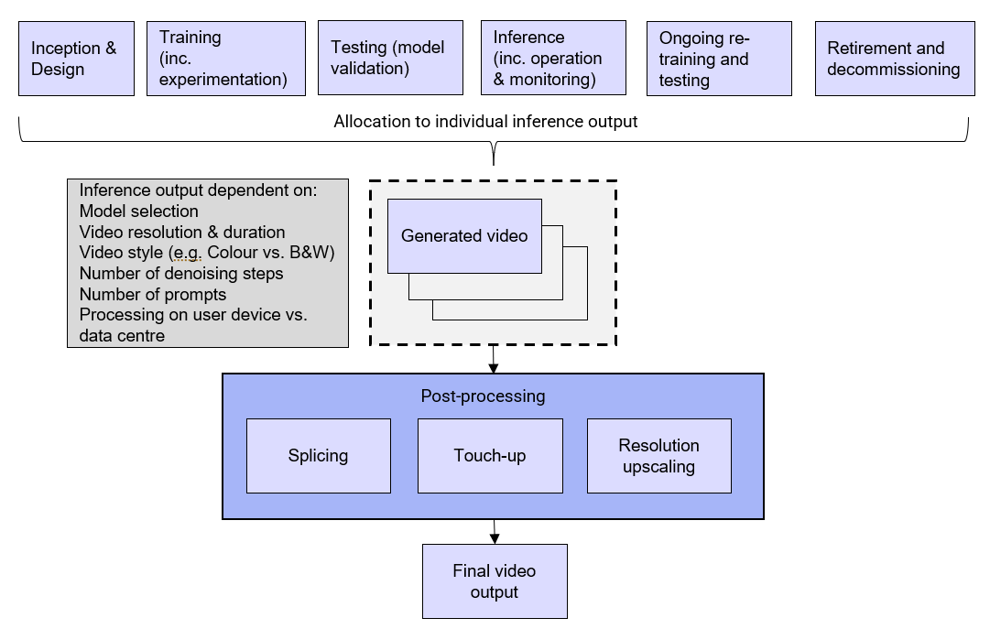
Figure 11. Conceptual schematic of generated video asset lifecycle boundary
Finally, we acknowledge that for a final video asset, the resulting carbon impact is affected by the quantity of videos generated and as well as by an array of post-processing activities, so these have been included in the boundary for completeness, but are highly dependent on the specific video asset and production processes used.
  - Functional unit
When measuring the carbon impact of a product, the functional unit serves as a unit of analysis for defined characteristics of the product. We seek to explore and define best practice functional units (FUs) which can be used to measure the carbon impact of generative AI, with specific functional units defined for model training, inference and video generation application.
Selecting an appropriate functional unit requires understanding why the product was created, what its intended purpose is and what characteristics define the level of quality that the product offers.
Example functional units
Smartphone: Lifecycle emissions over a smartphone’s 5-year life for everyday consumer use as a multi-purpose communications device (in this example, the product was created to meet consumer demand for a communications solution, intended for use as a multi-purpose communications device for “everyday” uses such as phone calls, web browsing and social media, over a defined service life of 5 years).
Video streaming: Lifecycle emissions per minute of video streamed on a smart TV at 4K UHD and 60 fps.
    - Evaluation of functional unit with reference to existing methodologies
Two key themes are apparent from reviewing existing methodologies to measure the carbon impact of AI systems and services.
Distinction between AI system evaluation vs. AI service evaluation
AFNOR Spec 2314 makes a distinction between the determination of a functional unit for an AI system and an AI service. This way, there is more clarity for the impact of the model system itself as well as measurement of the total impact from a user perspective to access and use the model.
The AI system FU specified by AFNOR SPEC 2314 is “Providing the system for one year for x queries” and the AI service FU specified is “Providing the service for one year to all users”.
Similarly, Green Software Foundation’s Software Carbon Intensity for AI Specification makes a specific distinction between impact evaluation from the provider perspective and consumer perspective.
In this approach, the provider perspective accounts for the impacts from inception, design & development, deployment and retirement, while the consumer accounts for impacts from operation and monitoring (including inference) and retirement, but omits the preceding stages in the lifecycle.
In contrast to the approach taken in AFNOR SPEC 2314, GSF’s SCI for AI Specification makes a clear delineation between evaluating impact to develop and train a model compared to using the model.
Absolute vs. intensity measurements
AFNOR Spec 2314 and GSF’s SCI for AI Specification diverge in their approach to measuring and reporting impact through adoption of absolute and intensity-based measurement approaches. While AFNOR Spec 2314 is not explicit in this regard, using their proposed functional unit would capture the absolute emissions over a one-year period.
GSF’s SCI for AI adopts an intensity-based approach, where emissions from the model provider’s perspective are reported per unit of compute, per token or per parameter. From the consumer perspective, emissions are reported similarly, such as per image.
Both approaches have their merits and are acceptable according to PCF standards. Using an absolute measurement approach can prove more transparent by showing the full-view of the emissions profile, while an intensity-based approach allows for better comparison to other studies since results are normalised to a specific unit of measurement. Furthermore, from a user perspective, an intensity-based approach can be helpful to determine the impact per output of the AI service.
    - Proposed approach
For maximum clarity and usefulness for model developers, operators and end-users, we propose an approach which closely aligns and builds on these methodologies by delineating the measurement of carbon impact by training, inference and final video asset, as shown below. In doing so, we recognise that carbon impact measurement and reporting serve different needs for different groups.
Key to this approach is that the functional unit encompasses all attributable activities in the lifecycle for the measured outcome (see Figure 10 and Figure 11). So, for example, to measure the emissions impact of inference, we include an apportionment of emissions from training since the model is required to be trained in order to perform the inference and generate an output (see more about allocation in Section 4.3).
    - Unit of analysis for AI model training
Given the scale and significance of the carbon impact attributable to model training (see Figure 5), we propose the following approach for defining the unit of analysis for AI model training, which clearly expresses the total emissions required to train the model. As here we are particularly focused on the training aspect of the AI system lifecycle, we view the model after initial training as an “intermediate product” and omit certain lifecycle stages of the AI system (such as deployment, operation & monitoring, and retirement).
Due to the iterative nature of AI systems, we proposed a unit of analysis related to the initial launch of the model, as well as a unit of analysis related to ongoing re-training of the model.
Unit of analysis (at initial launch): total model creation emissions per fully trained model for use at initial rollout, including inception, design, training & testing.
Unit of analysis (ongoing): total emissions to re-train the model, over a specified time-period, including validation activities associated with each re-training cycle.
Additionally, intensity-based units of analysis may supplement the units of analysis above, as proposed by GSF’s SCI for AI.
    - Functional unit for AI inference
In defining a functional unit for AI inference, we expand the boundary to include the full AI system lifecycle per Figure 10 (i.e., cradle-to-grave approach), as we can determine the ultimate function of the model, such as generating a video.
Here we are primarily interested in inference for video generation and propose the functional unit below.
Functional unit (per inference): Lifecycle emissions (inception to retirement) per megapixel-frame of video at a specified duration, frame rate, resolution and using a specified model type, configured with a defined number of denoising steps.
Example functional unit: Lifecycle emissions per megapixel-frame for a generated 5-second video at 24 frames per second and 720p resolution using a text-to-video diffusion transformer model with 100 denoising steps.
We propose this approach, rather than a per token approach, because we expect that the relationship between resolution and token and duration and token to be quadratic, rather than linear (Delavande, Pierrard, & Luccioni, 2025), and for clarity so that users can understand the context of the resulting carbon impact values.
We also propose that model providers specify a range of functional units (e.g., per second at 30 fps and 1080p, per second at 60 fps and 1080p, per 5-second video at 24 fps and 720p) related to the capabilities of their model and usage patterns of their users, so that users can understand the relative impact incurred by changing parameters.
Video generation models which also generate audio
Some video generation models also produce audio with the resulting video output. In these cases, we recommend the functional unit above, however it should be made clear in the functional unit that audio is included, and the characteristics of the audio should be defined as well. We expect that video generation is significantly more energy and carbon intensive than audio generation (see Figure 7), hence the selection of functional unit best suited for video generation. When evaluating the carbon impact of audio generation specifically, a suitable functional unit should be selected that is appropriately linked to the audio generation model’s architecture.

This functional unit represents our view of the best balance between accuracy and feasibility in application. However, we acknowledge that the number of denoising steps, while critical to calculating emissions, may not be easily accessible to the user. This is an area where increased transparency from model vendors can help through publishing the standard number of steps or, better yet, providing flexibility to change this parameter.
Allocation approaches to develop the resulting carbon impact are explored further in Section 4.3.
For full transparency of system level impacts, we also propose a functional unit relating to the absolute emissions of the AI system, from inception to retirement, similar to AFNOR Spec 2314. Model providers should concurrently publish this figure at time of launch and update it periodically if impacts from ongoing use of the AI system vary significantly.
Functional unit (AI system): Lifecycle emissions (inception to retirement) to provide the AI system for a specified number of videos representative of expected user patterns over a specified lifetime of the model.

    - Functional unit for generated video asset
Finally, we evaluate the selection of functional unit for a generated video asset. This will be highly dependent on the specific use of AI video generation and the form of the final output and should be considered carefully on a case-by-case basis. We also note the further expanded boundary, as indicated in Figure 11, which includes the total quantity of videos generated and post-processing required for a production ready asset.
We propose some general examples based on applications from Table 1.
Functional unit (reshoots and visual effects): Lifecycle emissions per scene for a specified scene type (e.g., aerial shot, car chase, etc.) and level of quality (i.e., resolution, framerate, duration)
Functional unit (video generated ad): Lifecycle emissions per video advertisement at a specified level of quality (i.e., resolution, framerate and duration)
  - Allocation approach
As with any product that relies on shared processes, there must be a way to allocate, or apportion, shared processes to individual products as part of the carbon footprinting approach. This is certainly true for generative AI systems and services, which rely on shared computational hardware and data centre infrastructure.
    - Allocation approaches established in existing literature and methodologies
Allocation is a key aspect of product carbon footprinting and it is not a trivial task to determine the appropriate allocation approach, as the selected approach can significantly affect the carbon impact of the product being studied.
The fundamental principle for determining an allocation approach is that it should be based on the underlying physical relationships between the product and system. In other words, the allocation metric should relate the cause and effect between product and system level impacts.
For example, to determine the carbon impact for a pair of jeans we must understand the emissions attributable to the input materials, such as fabric. Through allocation, the total emissions from the fabric mill can be allocated by mass to the fabric produced in the mill, since we understand that the final output mass of fabric produced in the mill heavily influences the inputs, such as raw material and energy, used in the milling process (Greenhouse Gas Protocol, 2011).
AFNOR Spec 2314 covers this topic to establish allocation rules in alignment with the recommendations of the Digital Services PCR, where support services are allocated with a top-down method using a Power Usage Effectiveness (PUE) uplift factor. Green Software Foundation establishes an allocation approach for embodied carbon within the Software Carbon Intensity specification, allocated with both a time and resource share.
AWS’s recent Customer Carbon Footprint Methodology v3.0 establishes a comprehensive multi-tier allocation approach beginning with cluster-level emissions which are aggregated and allocated to rack-level emissions based on planned power draw, which in turn are allocated to specific cloud services with a usage-based allocation method and finally allocated to customer accounts based on physical allocation, where possible, and economic allocation as a fallback (Amazon Sustainability, 2025).
    - Allocating emissions to the functional unit level for training and inference
Allocation of emissions to AI model training
We first evaluate and propose an approach to allocate AI system emissions to model training, as shown in Table 4, following the schematic in Figure 10 and unit of analysis defined in Section 4.2.3.
Table 4. Allocation of emissions to AI model training
Emission source | AI model training
Operational  (IT hardware) | Direct measurement of IT hardware energy consumption (including IT capacity) based on training time (no allocation required)
Operational (Support services) | Physical allocation of support services energy consumption by applying a PUE uplift on energy consumed by IT hardware
Embodied  (IT hardware) | Physical allocation of amortised embodied emissions based on training time
Embodied (Building structure, support services) | Physical allocation of amortised embodied emissions based on planned power draw and provisioned time
Operational emissions of IT hardware should be captured through direct measurement of the IT hardware used for training, where possible, and the operational emissions of support services are accounted for by application of PUE of the data centre. The embodied emissions are first amortised, then allocated based on training time for IT hardware.
The amortised embodied emissions for building structure and support services are first allocated to the rack level using planned power draw relative to the building or cluster’s total power capacity and then allocated from rack level to training based on provisioned time.

Table 5. Amortisation approach for embodied emissions of IT hardware and building infrastructure
Amortisation of embodied emissions of IT hardware
The intent is to capture all embodied emissions associated with IT hardware and allocate them to the services that use that hardware over the lifetime of the hardware, so that no embodied emissions are left unallocated.
The proposed approach amortises the embodied emissions of the IT hardware over the useful life of the hardware. For example, embodied emissions of the GPUs are amortised by GPU-hours over the 5-year life of the GPU. The amortised emissions are then allocated with a time-based allocation.
Amortisation of embodied emissions of building structure and MEP
Amortisation and allocation of embodied emissions of the building structure and MEP is a complex topic and likely to be minimally material in many cases (see Table 3). It is therefore acceptable to rely on estimated proxies developed per inference or per token in the near-term.
Following a similar approach to the amortisation of IT hardware, the embodied emissions of building structure and MEP are amortised over the useful life of the building structure and MEP equipment, where the useful life is consistent with conventions established by financial depreciation schedules (typically around 30 years for building structure and 5 – 15 years for MEP).
Allocation of AI system emissions to AI inference by lifecycle stage
We next evaluate and propose an allocation approach of AI system emissions to inference, as shown in Table 6.
To allocate training emissions to inference, we propose allocating training emissions equally across all projected lifetime inferences, considering that more energy-intensive prompts are not necessarily based on a greater share of total training effort.
Tokens were the first option considered for allocating training emissions to individual prompts, due to their wide use in text-based models to approximate computational effort. They are not, however, well suited to video generation. For diffusion-based video models, model configuration factors — particularly the number of denoising steps — are significantly more influential than token count in determining inference energy (Li, 2024). We also note the non-linear relationship between token count and energy consumption as a weakness in this metric (Delavande, Pierrard, & Luccioni, 2025).

Table 6. Allocation of AI system emissions to AI inference
Emission source | AI system lifecycle stages
Emission source | Model creation (inc. training) | Model operating lifetime |  | Model end-of-life (e.g., Retirement & decommissioning)
Emission source | Model creation (inc. training) | Inference | Ongoing retraining and re-testing | Model end-of-life (e.g., Retirement & decommissioning)
Operational  (IT hardware) | Allocated per inference over projected lifetime* | Prediction model  or based on direct measurement allocated per megapixel-frame (capturing both active and idle capacity) | Allocated per inference over projected lifetime* | Allocated per inference over projected lifetime*
Operational (Non-IT hardware) | Allocated per inference over projected lifetime* | Apply PUE uplift | Allocated per inference over projected lifetime* | Allocated per inference over projected lifetime*
Embodied  (IT hardware) | Allocated per inference over projected lifetime* | Amortisation and allocation based on provisioned time or per megapixel-frame proxy | Allocated per inference over projected lifetime* | Allocated per inference over projected lifetime*
Embodied (Building structure, Non-IT hardware, MEP) | Allocated per inference over projected lifetime* | Amortisation and allocation based on planned power draw or per megapixel-frame proxy | Allocated per inference over projected lifetime* | Allocated per inference over projected lifetime*
*Based on share of estimated or forecasted number of inferences over model lifetime.

Given this, two alternatives approaches remain:
- Identify an allocation metric that better reflects a fair share of lifetime model use for each inference. While conceptually appealing, this requires forecasting not only lifetime inferences, but the characteristics of these to determine energy use.
- Allocate training emissions equally across all inferences over the model’s lifetime, regardless of prompt characteristics.
For methodological feasibility and transparency, we propose the second approach as less uncertainty is required in the prediction. We also consider that prompts requiring more inference energy did not necessarily require a proportionally greater share of model training effort.
For the inference lifecycle stage, specifically, we propose two methods to determine IT hardware energy consumption:
- A bottom-up prediction model which estimates energy consumption per inference
- Direct measurement of inference-related IT hardware consumption during a defined operating period (such as a year) and allocation based on megapixel-frames
Once the per inference energy consumption has been determined, then the energy consumption of support services is allocated by applying a PUE uplift.
For embodied carbon emissions of IT hardware, we propose one of two methods:
- Amortise and then allocate based on provisioned time of the hardware (rather than simply active time)
- Amortise and then allocate the amortised emissions based on number of inferences using an empirical or prediction model to translate between megapixel-frames and provisioned time.
Embodied carbon emissions of building structure support services follow the amortisation and allocation approach proposed in Table 6. This is likely a multi-step translation from data centre -> cluster -> rack -> inference. As we expect these emissions to be immaterial in many cases, we also propose a simplified estimation approach which uses average emissions intensity per inference for this infrastructure.

References
AFNOR. (2024). Spec 2314: General framework for Frugal AI. La Plaine Saint-Denis Cedex: AFNOR.
AI Energy Score. (2026). Retrieved from Hugging Face: https://huggingface.github.io/AIEnergyScore/#faq
Altman, S. (2025). The Gentle Singularity. Retrieved from https://blog.samaltman.com/the-gentle-singularity
Amazon Sustainability. (2025). AWS Customer Carbon Footprint Methodology v3.0. Retrieved from AWS: https://sustainability.aboutamazon.com/aws-customer-carbon-footprint-tool-methodology.pdf
ARUP. (2025). Circular thinking for data centres. Retrieved from ARUP: https://www.arup.com/insights/circular-thinking-for-data-centres/
Axios. (2025). America's data center growth hot spots, mapped. Retrieved from Axios: https://www.axios.com/2025/12/18/data-center-growth-map-states
Bandi, A. A. (2023). The power of generative ai: A review of requirements, models, input–output formats, evaluation metrics, and challenges. Future Internet, 15(8), 260.
BBC. (2025). OpenAI video app Sora hits 1 million downloads faster than ChatGPT. Retrieved from BBC: https://www.bbc.com/news/articles/crkjgrvg6z4o
BBC. (2025). OpenAI video app Sora hits 1 million downloads faster than ChatGPT. Retrieved from BBC: https://www.bbc.com/news/articles/crkjgrvg6z4o
Bengesi, S. E.-S. (2024). Advancements in generative AI: A comprehensive review of GANs, GPT, autoencoders, diffusion model, and transformers. IEEe Access, 12, 69812-69837.
Bloomberg. (2025). AI Data Centers Are Sending Power Bills Soaring. Retrieved from Bloomberg: https://www.bloomberg.com/graphics/2025-ai-data-centers-electricity-prices/?embedded-checkout=true
Caravaca, F., Cuevas, A., & Cuevas, R. (2025). From Prompts to Power: Measuring the Energy Footprint of LLM Inference.
CNET. (2025). Over 40 Million AI Videos Have Been Made With Google Veo 3 Since May: How My Expert Testing Went. Retrieved from CNET: https://www.cnet.com/tech/services-and-software/over-40-million-ai-videos-have-been-made-with-google-veo-3-since-may-how-my-expert-testing-went/
Delavande, J., Pierrard, R., & Luccioni, S. (2025). Video Killed the Energy Budget: Characterizing the Latency and Power Regimes of.
EIA. (n.d.). FAQs. Retrieved from EIA: https://www.eia.gov/tools/faqs/faq.php?id=97&t=3
Elsworth, C., Huang, K., Patterson, D., Schneider, Ian, Sedivy, R., & al, e. (2025). Measuring the Environmental Impact of Delivering AI at Google Scale. Mountain View, CA: Google.
Epoch AI. (2025). Over 30 AI models have been trained at the scale of GPT-4. Retrieved from Epoch AI: https://epoch.ai/data-insights/models-over-1e25-flop#:~:text=Our%20estimate%20of%20GPT%2D4,across%20a%20range%20of%20benchmarks.&text=Compute%20estimated%20using%20parameter%20count%20and%20dataset%20size.,-More%20information%20is
Faiz, A., Kaneda, S., Wang, R., Osi, R., Sharma, P., Chen, F., & Lei, J. (2024). LLM Carbon: Modeling the End-to-End Carbon Footprint of Large Language Models. ICLR 2024.
Greenhouse Gas Protocol. (2011). Product Life Cycle Accounting and Reporting Standard. World Resources Institute and Business Council for Sustainable Development.
IEA. (2025). CO2 emissions associated with electricity generation for data centres by case, 2020-2035. Retrieved from IEA: https://www.iea.org/data-and-statistics/charts/co2-emissions-associated-with-electricity-generation-for-data-centres-by-case-2020-2035
IEA. (2025a). Data centre electricity consumption in household electricity consumption equivalents, 2024. Retrieved from IEA: https://www.iea.org/data-and-statistics/charts/data-centre-electricity-consumption-in-household-electricity-consumption-equivalents-2024
IEA. (2025b). Energy and AI. France: IEA.
IEA. (2025c). Energy and AI: Executive Summary. Retrieved from IEA: https://www.iea.org/reports/energy-and-ai/executive-summary
ITU and WBA. (2025). Greening Digital Companies 2025. Geneva and Amsterdam: ITU and WBA.
Kamiya, G. &. (2025). Data Centre Energy Use: Critical Review of Models and Results. EDNA - IEA 4E TCP.
Li, B. Y. (2024). Carbon in motion: Characterizing Open-Sora on the sustainability of generative AI for video generation. ACM SIGENERGY Energy Informatics Review, 160-165.
Luccioni, A. S., Viguier, S., & Ligozat, A.-L. (2022). Estimating the Carbon Footprint of BLOOM, a 176B Parameter Language Model.
Luccioni, S. A., Jernite, Y., & Strubell, E. (2024). Power Hungry Processing: Watts Driving the Cost of AI Deployment.
Luccioni, S., Gamazaychikov, B., Alves de Costa, T., & Strubell, E. (2025). Misinformation by Omission: The Need for More Environmental Transparency in AI.
Meta. (2025a). Llama 3.1 Model Card. Retrieved from Github: https://github.com/meta-llama/llama-models/blob/main/models/llama3_1/MODEL_CARD.md
Meta. (2025b). Llama 4 Model Card. Retrieved from Github: https://github.com/meta-llama/llama-models/blob/main/models/llama4/MODEL_CARD.md
Mistral AI. (2025). Our contribution to a global environmental standard for AI. Retrieved from Mistral.ai: https://mistral.ai/news/our-contribution-to-a-global-environmental-standard-for-ai
ML.ENERGY. (2026). The ML.ENERGY Leaderboard. Retrieved from ML.ENERGY: https://ml.energy/leaderboard/
NPR. (2024). AI brings soaring emissions for Google and Microsoft, a major contributor to climate change. Retrieved from NPR: https://www.npr.org/2024/07/12/g-s1-9545/ai-brings-soaring-emissions-for-google-and-microsoft-a-major-contributor-to-climate-change
Passoni, R., Ronchini, F., Comanducci, L., Serizel, R., & Antonacci, F. (2025). Diffused Responsibility: Analyzing the Energy Consumption of Generative Text-to-Audio Diffusion Models.
Patreon. (2025, October). Ovi is Local Version of VEO 3 & SORA 2. Retrieved from https://www.patreon.com/posts/ovi-is-local-of-140978355
Patterson, D., Gonzalez, J., Le, Q., Liang, C., Munguia, L.-M., Rothchild, D., . . . Dean, J. (2021). Carbon Emissions and Large Neural Network Training.
Profile IT Solutions. (n.d.). Best Practices for Data Center Area Sizing Per Rack Based on Power Density. Retrieved from Profile IT Solutions: https://www.profileits.com/best-practices-for-data-center-area-sizing-per-rack-based-on-power-density/
Reuters. (2023). ChatGPT sets record for fastest-growing user base - analyst note. Retrieved from Reuters: https://www.reuters.com/technology/chatgpt-sets-record-fastest-growing-user-base-analyst-note-2023-02-01/
Schneider Electric. (2015). Guidelines for Specification of Data Center Power Density. Retrieved from Schneider Electric: https://www.se.com/id/en/download/document/SPD_NRAN-69ANM9_EN/
Shehabi, A. S. (2024). 2024 United States Data Center Energy Usage Report. Berkeley, CA: Lawrence Berkeley National Laboratory.
TechCrunch. (2025). ChatGPT’s user growth has slowed, report finds. Retrieved from TechCrunch: https://techcrunch.com/2025/12/05/chatgpts-user-growth-has-slowed-report-finds/
The Guardian. (2025). Revealed: Big tech’s new datacentres will take water from the world’s driest areas. Retrieved from The Guardian: https://www.theguardian.com/environment/2025/apr/09/big-tech-datacentres-water
The New York Times. (2025). U.S. Emissions Jumped in 2025 as Coal Power Rebounded. Retrieved from https://www.nytimes.com/2026/01/13/climate/us-emissions-2025-coal-power.html
The Verge. (2024). How much electricity does AI consume? Retrieved from The Verge: https://www.theverge.com/24066646/ai-electricity-energy-watts-generative-consumption
The Wall Street Journal. (2025). Google’s First AI Ad Avoids the Uncanny Valley by Casting a Turkey. Retrieved from The Wall Street Journal: https://www.wsj.com/articles/googles-first-ai-ad-avoids-the-uncanny-valley-by-casting-a-turkey-dafd3662?mod=rss_Technology
UNCTAD. (2025). AI market projected to hit $4.8 trillion by 2033, emerging as dominant frontier technology. Retrieved from UNCTAD: https://unctad.org/news/ai-market-projected-hit-48-trillion-2033-emerging-dominant-frontier-technology
UNEP. (2025). Emissions Gap Report 2025: Off target – Continued collective inaction. Nairobi: UNEP.
Uptime Institute. (2025). Density choices for AI training are increasingly complex. Retrieved from Uptime Institute: https://journal.uptimeinstitute.com/density-choices-for-ai-training-are-increasingly-complex/
Wu, C.-J., Raghavendra, R., Gupta, U., Acun, B., Ardalani, N., & et, a. (2022). Sustsainable AI: Environmental Implications, Challenges and Opportunities. Facebook AI.
Yahoo Finance. (2025). Microsoft CEO Satya Nadella Warns AI Could Lose 'Social Permission' If It Burns Energy Without Real-World Benefits In Health And Education. Retrieved from Yahoo Finance: https://finance.yahoo.com/news/microsoft-ceo-satya-nadella-warns-205620968.html?guccounter=1&guce_referrer=aHR0cHM6Ly93d3cuZ29vZ2xlLmNvbS8&guce_referrer_sig=AQAAAAIUPqWpJAGETiw2-9X2P7l4nsrZSnJRMxJcVWlCyGhIN4-xgcIVOXENq8nJ6LCy8OkVTmI0M0lgBkS-QAxkKv1HE-a1RX
Zewe, A. (2025). Explained: Generative AI’s environmental impact. Retrieved from MIT News: https://news.mit.edu/2025/explained-generative-ai-environmental-impact-0117

carbontrust.com
+44 (0) 20 7170 7000
Whilst reasonable steps have been taken to ensure that the information contained within this publication is correct, the authors, the Carbon Trust, its agents, contractors and subcontractors give no warranty and make no representation as to its accuracy and accept no liability for any errors or omissions. Any trademarks, service marks or logos used in this publication, and copyright in it, are the property of the Carbon Trust. Nothing in this publication shall be construed as granting any licence or right to use or reproduce any of the trademarks, service marks, logos, copyright or any proprietary information in any way without the Carbon Trust’s prior written permission. The Carbon Trust enforces infringements of its intellectual property rights to the full extent permitted by law.
The Carbon Trust is a company limited by guarantee and registered in England and Wales under Company number 4190230 with its Registered Office at: Level 5, Arbor 255, Blackfriars Rd, London SE1 9AX.
© The Carbon Trust 2025. All rights reserved.
Published in the UK: 2025

The two principal methodologies today being AFNOR’s “Frugal AI” Spec 2314 (a French Ministry for Ecological Transition and Territorial Cohesion initiative) and Green Software Foundation’s Software Carbon Intensity for AI Specification (SCI for AI).
At the time of writing this draft, the ITU-T L.1801 guidelines for measuring the environmental impact of AI have recently been released. These will be considered in more detail in the next iteration of this report.
The word “system” is used in contrast to “model” to indicate that the model sits within a wider structure which supports and enables the function of the model.
From this perspective, training would fall within the design and development stage and inference would fall within operation.
We further evaluated materiality with a more conservative estimate of building structure lifetime of 12 years and determined that the findings hold, as in the medium scenario, the embodied to IT emissions ratio only increased to 0.75%.
Data storage considers servers, outside of the AI data centres performing training or inference, storing information which is either used by models or created by models and delivered to end-users.
Network infrastructure considers telecommunications infrastructure used to transport data to and from the data centres performing training or inference. This includes customer premise equipment, though any such equipment within the data centres used for training and inference is considered included, as indicated by the blue ‘Networking’ box in Figure 10.
The iterative process used by diffusion models to convert noise into coherent video outputs. This process is identified as the primary of carbon emissions in one video generation model (Li, 2024).
The system includes the impact from AI model lifecycle elements for training, retraining and inference over a one-year period, while the AI service additionally includes the impacts of other elements required for the end-to-end service to function, such as web hosting servers and end-user devices.
Absolute emissions refer to all emissions in a certain boundary over a specific time period (e.g., total lifecycle emissions over the life of a car), while emissions intensity refers to emissions per unit of measurement (e.g., lifecycle emissions per km driven)
A unit of analysis is specified for intermediate products, rather than a functional unit, as the function of the product may be unknown as is the case with a multi-purpose generative AI model.
In the PCF world, this is referred to as a cradle-to-gate footprint.
This concept is covered in detail in the GHG Protocol Product Standard, Chapter 9.
PUE is a metric used to measure data centre efficiency by relating the overhead electricity consumption of a data centre (i.e., from support services like MEP) to its IT electricity consumption
The 5-year GPU life here is illustrative and many vary depending on accounting practices and real-world use

